Association „Latvian Movement for independent living”  Registration no. 40008150439  Address: Robežu str 6-1, Riga, LV–1004, Latvia  Phone.: +371 26176901, e-mail: inga.skestere@lkndz.lv | 

Children and young persons with intellectual disabilities in Latvia.
Latvian Movement for independent living in November 2010 has carried out the research on situation of children with intellectual disabilities and their families in Latvia.
There were 151 families involved in the study through completing the questionnaires. The questionnaires were elaborated in the way, that parents can also express their opinion through comments after every section. This brought the elements of qualitative research in the study.
Parents were asked to answer the questions regarding the
- diagnosing intellectual disability in childhood,
- availability and quality of health care services,
- rehabilitation/ habilitation services,
- education, social services,
- health care services for parents and
- long term care (institutional care).
Survey was carried out in all the 5 regions of Latvia.
60,3% of families taking part in survey, were living in urban area and 39,7% in country side.
When analyzing the family structure, it should be stressed that in 104 families from 151 families involved in survey or in 68,9 % of cases there were both parents – mother and father in family. In 10 families or 6,6% cases there were no parents and grandparents are taking care of the child or young person with intellectual disability. These data clearly demonstrates that the still existing stereotype opinion in society, that if in the family is born the child with intellectual disability the farther mostly leaves the family is wrong.
In 72,2% of families of child or youngster with intellectual disabilities have also other children. 43% of families have one more child, 19,2% have 2 more children and 6% 3 more children.
Level of education of parents: 37,1% of parents have university education, 27,2% have professional education, but 19,2% college education. Primary education have 16,6% of parents. It should be stressed, that quite high percentage of parents high education level.

Disability structure
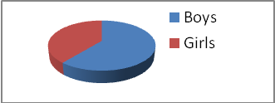. | In 92 cases or 60,9% the child/young person having intellectual disability was boy and in 59 or 39,1% was girl.

The age of children/young person’s having intellectual disability varied from 1 to 25, with average age of 14 years. Division in age groups: 13% pre-school age children (from 1 to 6 years of age), 72% are school age children (from 7 to 20 years old) and 15% are young persons of age 21 to 25.
The degree of intellectual disabilities varied from mild to profound. 10,6% child or young person with intellectual disability have Mild mental retardation, in 39,7% cases the degree is Moderate, 27,2% has Severe mental retardation and 22,5% of children/young person’s have Profound mental retardation. | 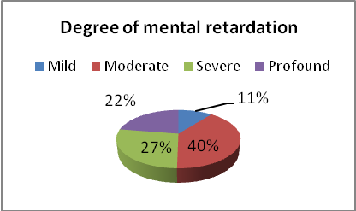

58 children/young persons or 38,4% additionally to the intellectual disability have also other functional disorders, what actually makes their level of disability more severe.
Diagnosing intellectual disability in childhood
The point of diagnosis of child’s disability is always dramatic for the parents, therefore the support at this moment is crucial for families further functioning.
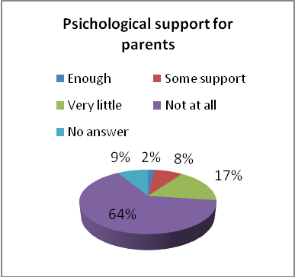 | Survey shows that 97 parents from 151 or 64,2 % after the diagnosing the intellectual disability of their child have not received any psychological support, and 17,2% stated that they have received almost no or very little psychological support. That means that 81,4% of parents when they get know that their child have intellectual disability was in great lack of psychological support. Only 2% (3 parents) estimate the psychological support as sufficient and 12 parents (7,9%) says, that they have received some psychological support but it should be more extensive. This clearly shows the situation in Latvia, where families are left without very crucial psychological support and it can very easily lead to the self-isolation of family and long term period of grief.
Parents are stressing that the time when the diagnosis was defined was terrible because of the lack of psychological support. Parent of boy with severe mental retardation remember “… medical professionals were taking care about the child. I had no psychological support. It was so terribly hard if You do not understand what happening with the child and how to survive with that”. Another parent tells: “…the medical personal didn’t explain me anything. I can just suspect, that it is not well at all. Doctors said that there will be necessary investigations. But he was not able to tell me in simple way, so that I can understand – what the problem is. There was terrible uncertainty. Doctors tried to say that it would be better to give the child away to long term care institution. There was no psychological support available anywhere…”
Survey shows that this kind of suggestions have been hard emotional experience and that words that parents have heard from doctors still hurt them. Mother of child with severe intellectual disability says ”….doctors brought me the official papers to fill in for to leave the child for state care as the child will never be able to take care of himself. And that I’m young and will have other – healthy children”. Mother of child with profound mental retardation tells “…doctor said not to worry, as the child anyway soon will die”.
Parents were asked if after the diagnosing the intellectual disability of child they have received enough information about the intellectual disability, perspectives of development of the child, available support and services. This kind of information is important for parents to be able understand the necessary steps of concrete action for further well-being and development of child’s potential.
80,1% of parents underlined, that they have not received any (37,7%) or almost any information (42,4%) about the intellectual disability. And only 5 (3,3%) parents pointed out that there have been information enough. If there is received the information, it is too often given is so complicated way, that parents simply do not understand the meaning, for example, ”Doctor explained me the diagnosis and possible future using only medical terminology. Further it was suggested to give the child away as he will anyway even not recognize the mother and I can have another children”. This is very often met comment from parents. There have been also situations when the professional medical literature have been given to the parents instead of understandable format information: “” ..when the diagnosis was set, the doctor gave me special medical literature for professionals”.
Quite similar situation is regarding the information about the possible perspectives of child development. 80,8% parents stresses that they have not received any information of this kind (39,7%) or that the information have been very limited (41,1%). Only 4 parents (2,6%) sates that they had enough information about the perspectives of child development in the future. Parent of girl with moderate mental retardation tells “ … nobody helped me with information. I was used to search for the information on my own and try to understand everything”.
Information about what kind of support is available in their new situation completely lacked 42,4 % and had very limited such kind of information 34,4% from all respondents. That means 76,8% of respondents were left with no or almost no information about the possibilities of getting support. Only in 3,3% of cases parents have been completely satisfied with the provided information.
In fact the research indicates that 127 parents from 151 (84,1%) lack or had no information even where they can search the possible support or services.
57% of parents had no information about the parents organisations or support groups and 19,9% of parents states that they have received just some information of this kind. Satisfied with the information about the parents support groups and organizations were only 7 parents (4,6%) and quite satisfied were 18 parents or 11,9%.
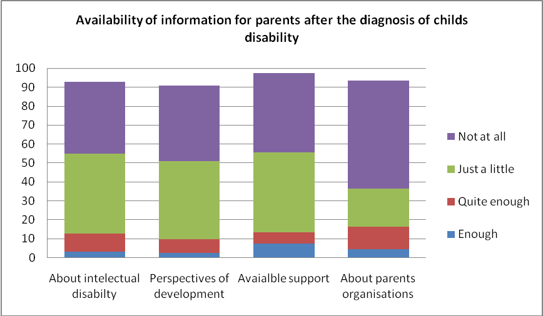
Data lead to the conclusion that families after the diagnosis of child’s disability have been left with no information about what is the intellectual disability, how it can affect the development of child, what could be done and what are the perspectives of development. Furthermore, parents are left without the information what kind of support is available and where they can get the necessary support. This can lead to the growing stress in the family and as according to the data there have not been available also the psychological support, the family can find themselves in the situation of social exclusion.
Parents were asked to evaluate how informed they feel now, when they have taken care about their child with intellectual disabilities for years, in regards to the information access. The answers show that parents are more informed today where they can receive the necessary information – 15,9% of parents feel completely informed and for 35,8% it is quite clear. But still quite high is the percentage of parents who do not have or do not have enough information - 42,4%. That means at least every third parent is still in great lack of information and in this case it is great threat that their children with intellectual disability can be left without the appropriate support. And this is still big problem for many parents to find the appropriate information “The attitude of medical personal is mainly very formal and refusal: like “go there and there” and look for “this and that” But when we go and look for what was suggested, it do not fit to our needs and is completely inappropriate”. Parents tells that most of the information they are still getting from other parents and not from the professionals.
There is also the tendency for children with mild and moderate retardation, that the diagnosis is set up very late - only at school age. Parents story: “… my child was not speaking until the age of 4. When the child was 6 years old, it was suggested to give the child to the special school and only then the mental retardation was detected”.

Availability of health care services for children/young persons with intellectual disabilities.
Availability of health care services for the child or youngster with intellectual disabilities as satisfactory estimates only 10 from 151 parents involved in the research, or 6,6% of respondents. As quite good, but stating that it could be better, health care services have been estimated by 37,1% parents. The same percentage of parents - 37,1%, states that availability of the health care services is bad, but 14,6% of parents thinks that health care is not available for their child or young person with intellectual disability. That means - at least every second (51,7%) of parents experience the bad availability for health care services for their child with intellectual disability. This can lead to the bad health condition of children with intellectual disabilities and raises the cases of untreated chronic illnesses.
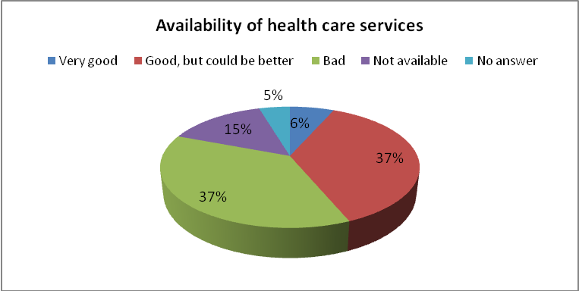
Parents were asked how much interest express the primary health care doctors (family doctors) about the health condition of child/young person with intellectual disability. 17,2% of parents pointed that their family doctor is regularly showing interest about the health conditions of child or youngster. 16,6% said that their doctor only rarely asks about the health conditions of the child. In the most cases – 49,7% the family doctor is showing any interest only when the child or young person with disability is already ill. 11,2% of parents told that doctor is consulting the family only via phone or is prescribing the medicine without examination of child’s health conditions. Mother tells: “Our family doctors knows about the diagnosis of the child, but shows any interest only when we need official documents to confirm disability status. If the child has any pain, that doctor is saying that this is because of nervousness. This is so humiliating and hard.” There are some success stories, when parents manage to find the interested medicals: “ … we have found couple of doctors with whom we can communicate and who have at least some understanding about our situation. “
These results confirms that the preventive work in health care for children with intellectual disabilities must be improved significantly.
Almost every second parent (49,7%) is saying that during the visit to the health care establishment the medical personal is just a little bit trying to communicate with the child or young person himself/herself and 12,6% stresses that medical personal is not at all communicating with the child with intellectual disability, but only with parent.
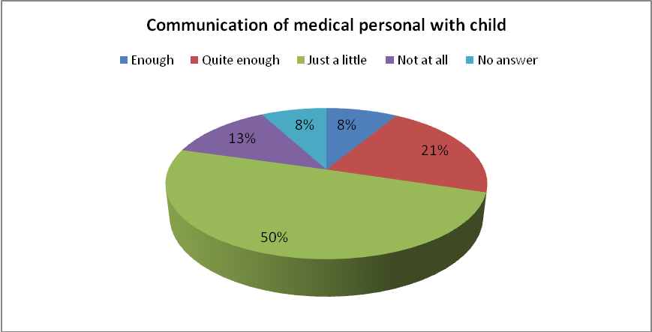
Every third parent (35,1%) evaluates the knowledge of medical personal about the intellectual disabilities as weak and 8,6% stresses that personal do not know anything about intellectual disabilities. 9 parents from 151 (6%) values the knowledge of medical personal as very good, and in most of cases such a high estimation have received the specialists in the field of intellectual disabilities and not general medical personal. Sometimes parents are used to learn themselves about the diagnosis of their child and try to find out what medical support their child could get: “If I’m asking something to doctor – medicine or visit to specialist, then doctor gives it to us. We are ourselves trying to find out what investigations the child need and to which specialist we must go.” Only 3,3% (5 parents) of respondents thinks that medical personal have understanding and are able to use the methods of alternative communication and also these are the cases of specialists, like speech therapists.
Availability of rehabilitation/habilitation services for children/young persons with intellectual disabilities.
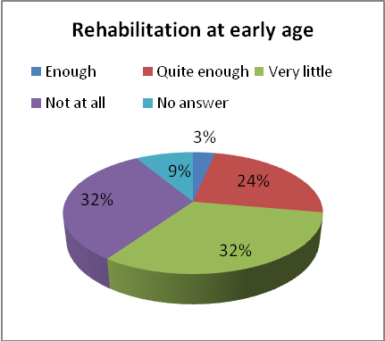 | Parents were asked if their children in early age had opportunity to receive the rehabilitation services. 31,8% parents stressed that their children had no opportunity to receive any rehabilitation and the same percentage said that their children had very few opportunity to have any rehabilitation. That means that 63,6% of children with intellectual disabilities didn’t receive the rehabilitation in early age and there is wasted the time when the early intervention is most effective one. At the same time it can limit the child’s development potential. 3,3% (5 children from 151) have received enough rehabilitation and 24,5% quite enough. The number of children who have received the rehabilitation should be estimated as very low.

For those children with intellectual disabilities who had the opportunity to receive the rehabilitation at early age, it was still not always available as soon as the need for rehabilitation has been identified. 44,4% of parents whose children received the rehabilitation at early age stressed that the rehabilitation service was provided too late or unacceptably late. Only 13,9% of parents thinks that rehabilitation was provided at appropriate timing. Parents for rural area states that it is very difficult to go to the rehabilitation centers as they are very few in state and far away from their local communities, but there are not available any community-based rehabilitation.
Asked about the today situation 42,4% parents stresses that their child or young person with intellectual disability do not have opportunity to receive any rehabilitation and 19,9% were not able to answer the question, what could mean that also these children or young persons do not have opportunity of rehabilitation. 17,9% receives rehabilitation every year and these more likely are children under age of 18 having physical disability in addition to intellectual disability. 9,3% receives rehabilitation once in two years. Parents feel quite unhappy with the situation, that rehabilitation is available only until the age of 18 and afterwards parents must pay the full price themselves, what makes it impossible to receive the service. Mother of girl with multiple disability tells: “for last time we were in national rehabilitation centre before my daughter became 18 years old. Now my daughter do not have any rehabilitation opportunity”.
Only 9,3% (14 parents) answers that their child or young person with intellectual disability have individual rehabilitation plan and only 6 parents have been involved in development of such plan. This can also be the case of unsatisfactory communication between the rehabilitation personal and the family and shows that the involvement of family in the rehabilitation of child is too limited. As the result is very fragmented rehabilitation process, because the results show that there is no plan for the families for the further rehabilitation activities in local community what can remarkably lower the effectiveness of rehabilitation process.
61,4% of parents are using their private financial resources to pay for the rehabilitation of their child or youngster and in addition 22,8% have used also contribution from charity donations. These private resources mostly have been used to cover part or all the costs of rehabilitation. Low availability of rehabilitation services forces many parents to try find the service abroad and on their own expenses “There so few opportunities in Latvia. Parents must try to find some opportunities abroad and also to try finance it ourselves. We have managed to find good quality service in USA „Institutes for the achievement of human potential”, where our child receives rehabilitation”.
Education.
58,2% of children have attended the pre-school education establishment (31,1% mainstream kindergarten and 27,8% special education pre-school establishments). 40,4% of children have never attended the kindergarten and have stayed at home until the school age. For these children have been denied the pedagogical support which they could receive if the pre-school education would be available. The mainstream kindergarten has been attended mostly by children with mild mental retardation and in many cases the mental retardation have not be detected in the early age, but only when the child is reaching the school age.
From school-age children (7 to 20 years) 66,9% are attending special schools ( 35,3% are staying during the week in special boarding school and have opportunity to be with family only in holidays). 15,1% are attending the inclusive class in mainstream school and all these are children with mild mental retardation. 4,3% of children receive education at home – teacher from school is coming home for couple of hours once a week. 13,7% of children and young persons with intellectual disabilities have never attended the school and this is unacceptably high percentage, showing that every 7th child with intellectual disability is out of education system.
92% from those children who are learning at school do it on every day basis – they are attending school every day except holidays.
51,7% of parents says that they are informed enough or quite informed about the educational program of their child and 59% think that they have good enough or very good cooperation with the educational establishment of their child. But still every second parent is not informed about the education program of his/her child at the school. For example, parent says “I do not know what the child has learned in the school and I’m afraid that actually the child has not learned anything”. This highlights the same lack of cooperation with families which was seen in the provision of rehabilitation services and proves that this is cross-sectoral problem.
From children with intellectual disabilities attending school 29% or at least every fourth child have learned the alternative communication methods and 97% from the schoolchildren who have learned alternative communication uses it in their daily life. Parent tells: “Even in special school there is nobody who could teach child the alternative communication. Child has speech problems, but he can and wants to communicate. Child tries to create his own sign language, but it is so hard to understand him and there is nobody who could help him”.
Many parents stress that they do not know what is alternative communication and what could be the benefit for the child if he/she learns the alternative communication method.

Availability of social services for children/young persons with intellectual disabilities.
Parents were asked to evaluate the availability and variety of necessary social services in their local municipality according to the needs of child/young person with intellectual disability. Only 6,6% (10 from 151) marked that there are enough social services. 6% of parents said, that there are some social services, but it is not enough. 28,5% stressed that there are very few services available for children/young persons with intellectual disabilities in the local municipalities, 28,5% were completely unsatisfied with variety of services, but 30,5% of parents were not able to answer anything about the services what shows that also children or young persons of these parents do not receive the services.
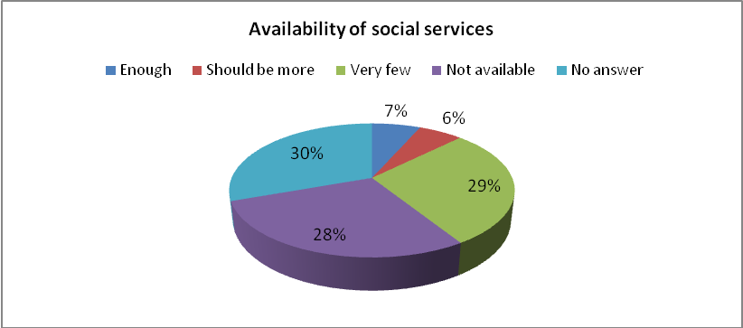
Situation with availability of social services for children and young persons with intellectual disabilities should therefore be estimated as critical. Existing situation leads to the exclusion of parents from labor market, lower income and higher poverty risk of families (even if the child is attending the school, but after the school there are no services, at least one of the parents is used to stay at home). At the same time the needs of child for the appropriate support are not met. This can also lead to the higher risk of institunalisation of the child.
68,9% parents stated that they have very limited or even no information about the social services which could be provided in local municipality. Survey also shows that there is very limited understanding about what is social service as many parents state that the child receives disability benefit. Mother is stating “… I do not know what it means – social service. My child receives the disability benefit and I use it all to pay to the person who looks after the child.”
When parents were asked to think about the future life of the child/young person with intellectual disability, 59,6% said that in future to have a good quality of life, their youngster will need day centre, 44,4% – that it will be necessary group flat, for 41,7% important would be supported employment opportunities, 38,4% would need sheltered workshop, 51% are looking forward for support of assistant and 43% said that there should be available peer support groups. These data clearly states the needs of children and young persons with intellectual disabilities and should serve as the evidence that families are looking forward for community based services and not long term institutional care. But at the same time parents actually do not believe that their child will in future receive the services. Father is saying “.. I do not believe that there will be developed services for our children, event the minimum of services”. There is stressed by parents also the low level of awareness on the local community decision making level – “… there is no understanding on local municipality level, therefore they are not motivated to develop the variety of community based services”.
But still 63,6% of parents have opinion, that they do not have enough information about what kind of services could be necessary for their child/young person. Lack of information and knowledge often leads to the very weak ability to advocate for the rights of the children and young people with intellectual disabilities. Father of severely intellectually disabled child says “… I must look myself for all kind of information. Otherwise nobody gives me any information”.

Availability of health care services for the parents
Parents were asked how often they visit family doctor to examine their health condition. 25,8% of parents pointed that they visit family doctor regularly and 25,8% that they visit, but no regularly. 12,6% visit family doctor very rarely and 35,8% do not visit doctor for prophylactic examinations, just in case of acute illness. That means 48,4% or almost half of all parents do not have opportunity to take care of their health condition. One of the reasons for this troubling situation is of course the unavailability of social services. Especially when the child or young person have severe or profound mental retardation and there is not support available, parents are used to devote all their time and attention to the child and family life and have no opportunity to take care of their health condition. Another problem is not existing respite services. Parents too often do not have any place, where child can stay even if parents are in urgent need of treatment or rehabilitation: “… doctors are already long time ago saying, that I need rehabilitation. But I do not have any place where to leave my child and be aware that he feels well and is safe”.
Only 27 parents or 17,9% of all parents have available the consultations of psychologist according to the needs. 13,9% have opportunity to get consultation of psychologist, but not on regular basis and not when the consultation is needed. For 41,1% of parents there is no opportunity to receive the necessary consultation of psychologist. These parents even if the case of high stress or situation of crisis are left alone with their problems and it can seriously impact the health conditions of parents. Family is telling “I would be so glad if me and my husband would have the consultations of psychologist available. But it costs so much… The psychologist of my son helps us a little, as if I must say the truth – it is so hard for us – parents. We want to be a good support for our child, but sometime we do not manage as we lack ourselves the necessary support”. For 62,3% of parents there have not been available rehabilitation services. 24,5% or every fourth of parents have used the rehabilitation services but the expenses have been fully covered by the parent himself/herself. It should be stated that in Latvia are no rehabilitation programs for parents of disabled children and this question have never been on agenda.
Long term care for children/young persons with intellectual disabilities.
Parents were asked if at any period of their child life they have got suggestion to give their child away to the long term residential institution and 42,4% of parents have received such suggestion (26,5% soon after the diagnosis of child’s disability and 15,9% in the later life period).
From those cases when it was suggested to leave the child in long term care institution, most often - in 43 from 64 cases it was given by medical personal (67,2%) and in 16 cases (25%) such advice was given by social worker. There are also some cases when suggestion to leave the child in institution comes from teacher, relatives or friends.
Parents were asked if they would choose to leave their child/young person with intellectual disability in long term care institution. 92% of parents said that they would never do it and they would try to find any other solution as this kind of service do not meet the needs of children/young persons with intellectual disabilities. 7,3% said that they would choose this kind of service as there are no other choices for the moment. And only 1 parent said, that would be ready to put the child in long term care institution. This clearly shows that the choice when parents put their child or young person in institution is forced choice, due to the lack of alternatives and appropriate support, and not a free will of family. This has been emotionally hard question and many parents stated that “… I will do everything possible for my child not to put him in long term care institution”, or “…this will never happen until I will be alive” and at the same time parents are saying “… I’m so afraid about the future life of my child” and asking “what will happen with our child when we will not be able to take care anymore?”.

